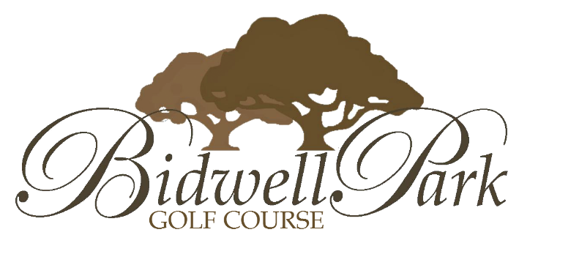

Nine & Dine Golf Events
$45.00 per Person

Includes:
- 9-Hole Green Fee
- 9-Hole Shared Cart Fee
- $5 Tee Prize/Gift Card
- Dinner
Golf Tournament, Fundraisers, Company Outings…..
Reduce cost & reduce time
Evening event starting at 5:00 or 5:30
NO MORE “HIGH” entry fees
Attract more players
Same profits for your event
“Less Time” commitment for players & organizers
9-Hole Shotgun
9-Hole Scramble

*Maximum of 72 Players*

Contact JT Linnet or Courtney Foster @ 530-891-8417 to learn more and to book your event.

